CENTENNIAL COLLEGE
Information and Communication Engineering Technology (ICET)
Project & Assignment 2
SEMESTER: WINTER 2017

SUBJECT NAME: Introduction To Database Concept

SUBJECT CODE: COMP122

INSTRUCTOR NAME: ERSAN CAM

WEIGHTING: 30 % Total both Assignment 2 and Project
Not: When you receive grade from this work (say 70) this will be applied as Project work and as well as 70 mark for your Assigment-2

Due Date: March31st midnight is due date. Late submission will lose 15 points.

Instructions

Download and execute following files in your SQL Developer screen

Files : CityJail_Oracle.sql , Book_Order_Oracle.sql , Book_Order_ReportingNeeds.png and City_Jail_ReportingNeeds.png

All Files are under Assigment2_ProjectWork (%30) Folder under Content

When you open the file CityJail file , there must be CREATE TABLE section to create all tables and after that ALTER TABLE to add CONSTRAINTS.

Section A (30 pnts)

Prep work: In this part of the project , students needs to understand how a Database physical structure is being build , Rather than just executing above script… Students must understand what they are running to build CityJail database system

Answer below questions only based on CityJail_Oracle.sql file
- List all of the Primary Key Columns defined for each Table
- List all of the Foreign Keys for each table? And each of those Foreign Key which Parent table they are referencing.
- Is there any CHECK Constraint defined? If Yes on Which table

=============
Section B ( 50 pnts)

Prepare below reports for City Jail management Officer… Find solution for all 5 items below

Look for City City_Jail_RportingNeeds.png to answer questions

Or
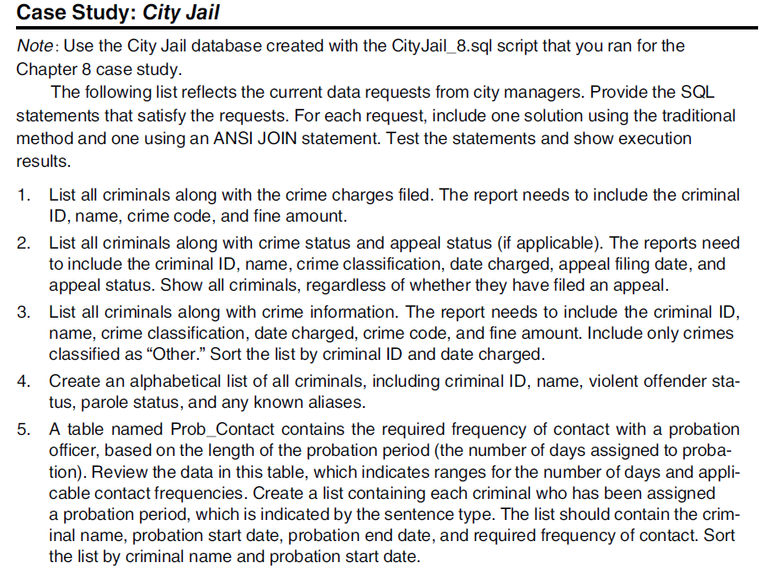

===================
Section C (20 pnts)
Choose 2 questions from below list and answer them based on BookOrder management database

Look for City Book_Order_Reports.png to answer questions

